**MENTOR MEDIA LTD**

**Freight Rates (FR)**

**Entity Relationship Diagram**

**IMPORTANT**

This information contain herein is the proprietary property of Mentor Media Ltd.

The holder agrees to the following:

1. Not to reproduce or copy it;
2. Not to reveal or publish it in whole or part;and
3. To maintain this document in confidence Framework & Standards

RELEASE HISTORY

|  |  |  |
| --- | --- | --- |
| Release No | Content | Effective Date |
| 1 | Create basic modules | 10 rd May 2021 |
| 2 | Update ERD diagram | 3rd August 2021 |
|  |  |  |
|  |  |  |
|  |  |  |
|  |  |  |
|  |  |  |
|  |  |  |

|  |  |  |  |
| --- | --- | --- | --- |
| Prepared by | Thanh Trinh | Date | Sign |
| Designation | System Developer |
| Reviewed By |  | Date | Sign |
| Designation |  |
| Approved By |  | Date | Sign |
| Designation |  |
| Document No | Total no of the Pages (Excluding the cover page) : | | Release 1 |

Table of Contents

1. Database & Coding Standardization 4

1.1 View & Stored Procedure Naming Convention 4

1.2 View & Stored Procedure Revision Comment Format 4

1.3 Standard Message 5

2. Calculator 6

2.1 MS_CARRIER 6

2.2 MS_ SERVICE_TYPE 7

2.3 REF_PACKAGE_TYPE 7

2.4 MS_CARRIER_PACKAGE_TYPE 7

2.5 MS_EXCEL_WEIGHT_RATE 7

2.6 REF_COUNTRY 8

3. Upload Rate 9

3.1 MS_CARRIER 9

3.2 MS_EXCEL_WEIGHT_RATE 10

4. Other tables 11

MS_USER 11

MS_CONFIGURATION 11

# 1. Database & Coding Standardization

## 1.1 View & Stored Procedure Naming Convention

The name of view and stored procedure must follow as below:

|  |  |
| --- | --- |
| View Naming | Remarks |
| SV_REF_XXX | Base view for reference |
| SV_MS_XXX | Base view for master |
| SV_TR_XXX | Base view for transaction table |
| SV_XXX | View to be use in module |
| RV_XXX | View for report |

|  |  |
| --- | --- |
| Procedure Naming | Remarks |
| SP_WEB_[tablename] | Procedure for insert/update/delete purpose |
| SP_WEB_[tablename]_GET_XXX | Procedure for select purpose |
| RP_WEB_XXX | Procedure for report |
| FN_XXXX | Function for getting value |

## 1.2 View & Stored Procedure Revision Comment Format

* Every view and stored procedure must include the standard format below on the above  
  of the view/stored procedure name.
* Every change on the view/stored procedure must add a new version with edited date,  
  author name and the change description under revision history.
* 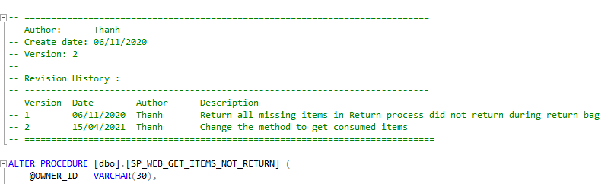The latest version must be updated at every change.

The latest version of this

view/store procedure

## 1.3 Standard Message

|  |  |  |
| --- | --- | --- |
| Module Name | Scenario | Message |
| General | No record found | No record found for %. |
| General | Mandatory field | This field is required. |
| General | Duplicated record | Duplicate record found for %. |
|  |  |  |
|  |  |  |
|  |  |  |
|  |  |  |
|  |  |  |

# 2. Calculator

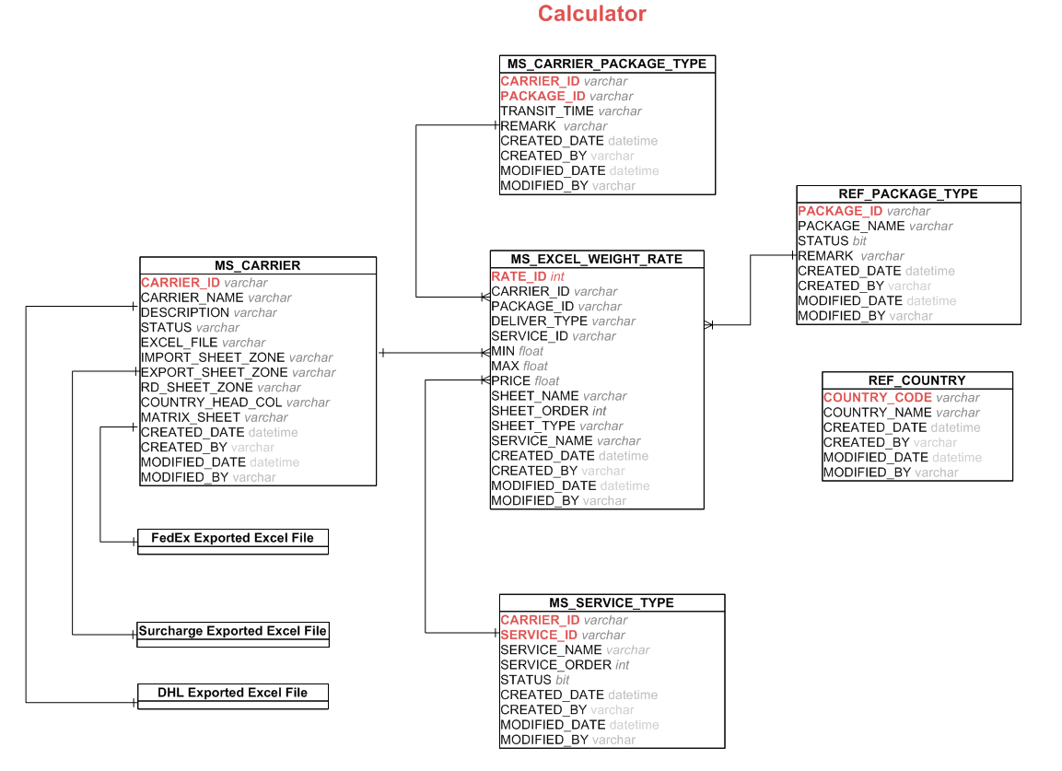

**2.1 MS_CARRIER**

This table keep every carrier in the system

|  |  |
| --- | --- |
| **Column Name** | **Description** |
| CARRIER_ID | The id of the carrier |
| CARRIER_NAME | The name of the carrier |
| DESCRIPTION | The short description of the carrier |
| STATUS | ACTIVE or OBS. The value refers to REF_STATUS_TYPE table with type CARRIER_STATUS. Default value is ACTIVE |
| EXCEL_FILE | This fileld is stored the excel file name that was exported by another team. The system will get data in the file. The file has many sheets which defined the price for each deliver type and package type. The file has contained the zone, the matrix that look up to calculate the price of freight rate base on the carrier... |
| IMPORT_SHEET_ZONE | The sheet name (in the excel file) which stores all country names and zone code for each country. It is only used for **Import** type. |
| EXPORT_SHEET_ZONE | The sheet name (in the excel file) which stores all country names and zone code for each country. It is only used for **Export** type. |
| RD_SHEET_ZONE | The sheet name (in the excel file) which stores all country names and zone code for each country. It is only used for **Third-party** type. |
| MATRIX_SHEET | The sheet name (in the excel file) which stores all zone codes for origin country and destination country. It is only used for **Third-party** type. |
| COUNTRY_HEAD_COL | This field will store the first header column of all country in all sheets that contains countries and zone codes. |

## 2.2 MS_ SERVICE_TYPE

This table keeps all list of service type of all carriers in the system.

|  |  |
| --- | --- |
| **Column Name** | **Description** |
| CARRIER_ID | The id of carrier. |
| SERVICE_ID | The id of the service. |
| SERVICE_NAME | The name of the service. |
| SERVICE_ORDER | The order of service. |
| STATUS | This Status of the service. It has Y/N value. Default value is Y |

## 2.3 REF_PACKAGE_TYPE

This table keeps a list of package type for each carrier in the system

|  |  |
| --- | --- |
| **Column Name** | **Description** |
| PACKAGE_ID | The id of package type. |
| PAKCAGE_NAME | Type of package:Envelope(Doc), Pak, Package, NIL... |
| REMARK | The short description of the package type. |

## 2.4 MS_CARRIER_PACKAGE_TYPE

This table keeps a list of type of package type based on the carrier

|  |  |
| --- | --- |
| **Column Name** | **Description** |
| CARRIER_ID | The id of the carrier |
| PACKAGE_ID | The id of package type. |
| TRANSIT_TIME | The transit lead time that counted by working days |
| REMARK | The short description of the package type. |

## 2.5 MS_EXCEL_WEIGHT_RATE

This table keeps a list of sheet names in the excel file based on the carrier.

|  |  |
| --- | --- |
| **Column Name** | **Description** |
| CARRIER_ID | The id of the carrier |
| ZONE_CODE | The code of zone |
| SERVICE_ID | Type of the service. It reference from **REF_SERVICE_TYPE** table |
| DELIVER_TYPE | The type of carrier's deliver. They are IMPORT, EXPORT, 3D PARTY. The value refers to REF_STATUS_TYPE table with type DELIEVER_TYPE. Default value is IMPORT |
| CARRIER_PACK_ID | The type of package base on the carrier. |
| MIN | Min weight value of product (start value of the range weight) |
| MAX | Max weight value of product (end value of the range weight) |
| PRICE | The price of this range weight |

**2.6 REF_COUNTRY**

|  |  |
| --- | --- |
| **Column Name** | **Description** |
| COUNTRY_CODE | The code of country |
| COUNTRY_NAME | The name of country |
| SHORT_NAME | The short name of the country |

**2.7 Exported Excel File**

**a. Surchage Exported Excel File**

The file has a surchage table rate based on each month for each carrier. It is external file which store in the server.

The files are contained the zone matrix that look up to calculate the price of freight rate base on the carrier. It is external file which store in the server.

**b. DHL Exported Excel File**

The file has contained all countries, zone code, the matrix table, price tables for each deliver type. The system will read data in it to calculate the price of freight rate base on the **DHL carrier**. It is external file which store in the server.

**c. FedEx Exported Excel File**

The file has contained all countries, zone code, the matrix table, price tables for each deliver type. The system will read data in it to calculate the price of freight rate base on the **FedEx carrier**. It is external file which store in the server.

# 3. Upload Rate

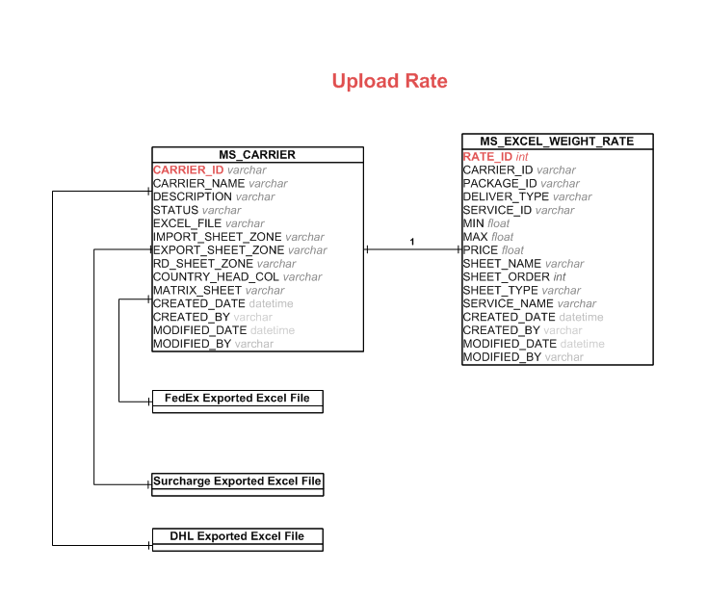

**3.1 MS_CARRIER**

This table keep every carrier in the system

|  |  |
| --- | --- |
| **Column Name** | **Description** |
| CARRIER_ID | The id of the carrier |
| CARRIER_NAME | The name of the carrier |
| DESCRIPTION | The short description of the carrier |
| STATUS | ACTIVE or OBS. The value refers to REF_STATUS_TYPE table with type CARRIER_STATUS. Default value is ACTIVE |
| EXCEL_FILE | This fileld is stored the excel file name that was exported by another team. The system will get data in the file. The file has many sheets which defined the price for each deliver type and package type. The file has contained the zone, the matrix that look up to calculate the price of freight rate base on the carrier... |
| IMPORT_SHEET_ZONE | The sheet name (in the excel file) which stores all country names and zone code for each country. It is only used for **Import** type. |
| EXPORT_SHEET_ZONE | The sheet name (in the excel file) which stores all country names and zone code for each country. It is only used for **Export** type. |
| RD_SHEET_ZONE | The sheet name (in the excel file) which stores all country names and zone code for each country. It is only used for **Third-party** type. |
| MATRIX_SHEET | The sheet name (in the excel file) which stores all zone codes for origin country and destination country. It is only used for **Third-party** type. |
| COUNTRY_HEAD_COL | This field will store the first header column of all country in all sheets that contains countries and zone codes. |

## 3.2 MS_EXCEL_WEIGHT_RATE

This table keeps a list of sheet names in the excel file based on the carrier.

|  |  |
| --- | --- |
| **Column Name** | **Description** |
| CARRIER_ID | The id of the carrier |
| ZONE_CODE | The code of zone |
| SERVICE_ID | Type of the service. It reference from **REF_SERVICE_TYPE** table |
| DELIVER_TYPE | The type of carrier's deliver. They are IMPORT, EXPORT, 3D PARTY. The value refers to REF_STATUS_TYPE table with type DELIEVER_TYPE. Default value is IMPORT |
| CARRIER_PACK_ID | The type of package base on the carrier. |
| MIN | Min weight value of product (start value of the range weight) |
| MAX | Max weight value of product (end value of the range weight) |
| PRICE | The price of this range weight |

**3.3 Exported Excel File**

**a. Surchage Exported Excel File**

The file has a surchage table rate based on each month for each carrier. It is external file which store in the server.

The files are contained the zone matrix that look up to calculate the price of freight rate base on the carrier. It is external file which store in the server.

**b. DHL Exported Excel File**

The file has contained all countries, zone code, the matrix table, price tables for each deliver type. The system will read data in it to calculate the price of freight rate base on the **DHL carrier**. It is external file which store in the server.

**c. FedEx Exported Excel File**

The file has contained all countries, zone code, the matrix table, price tables for each deliver type. The system will read data in it to calculate the price of freight rate base on the **FedEx carrier**. It is external file which store in the server.

# 4. Other tables

**REF_STATUS_TYPE**

This tables keep a list of status which used in the system.

## MS_USER

This tables keep all accounts which used to login the portal.

## MS_CONFIGURATION

This tables a list of parameters value and used for the system .